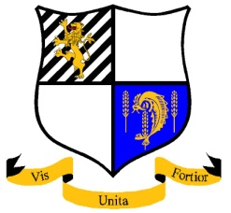
Purley John Fisher Rugby Football Club

Parson’s Pightle, Coulsdon Road, Old Coulsdon, Surrey CR5 1EE

Telephone: 01737 553042
Web site: www.pjfrfc.co.uk

Annual General Meeting Season 2017/18
Wednesday, June 6th
7.30pm for 8.00pm

Agenda

• Apologies

• Agreement of previous AGM minutes

• Chairman’s report (inc. officers reports)

• Secretarys report

• Treasurers report

• Election of Officers

10 minute Break

• AOB

Election of Officers:

Elected Officers: | Nominees
Chairman
Treasurer | Luke O’Shea
Secretary | Niel Kenny
1st XV Captain | Iain Greenwood
Marlin’s Captain
Barracuda’s Captain
Vet’s Captain
Fixture Secretary | Chris Doyle
House and Grounds | Bryan Whicher
Press Officer
Social Secretary
Merchandise and Equipment | Neil Leather

Non-elected Officers
President | Pat Liddiard

1st XV Manager

Marlin’s Manager

Coach
Events Manager | Mal Sharp
Membership Officer | Tim Wood
Web site Manager | Martin Cripps
RFU Tickets Officer | Paul Edwards

Medical Officer

TBC – To be confirmed

