Minutes of the AGM for 2017
Held at the club on Tuesday, June 13th

Apologies | Apologies were received unfortunately the recorded apologies were lost because of a computer malfunction
Attendees | 24 members attended the meeting
Chairman’s Report | Bryan summarised the season and talked through the work that had gone into maintaining the pitches and clubhouse. Bryan also gave an overview of the club’s finances which were holding up despite reduced bar takings and use. Bryan thanked Mal and Michelle Sharp for their work in running the bar and the social hires which were holding up well over the past year. Bryan also reported that a number of lunches had been held throughout the season.  There was some caution over maintaining the club’s turn over as the re-organisation of the Surrey leagues will see the club only playing 18 league matches in the coming season. The Club was therefore considering joining the RFUs Cup competition for the coming season.  Some progress had been made with EDF in resolving the Club’s electricity bill challenges. It is hoped that the situation would be resolved in the near future.  Bryan reported that the Club’s lease had run its course and was opening negotiations with Croydon to extend the lease. Croydon were proving hard to pin down and progress was slow. The Club had no worries over the situation as all the onus currently sat with Croydon to get things moving.  The Club again participated in Rugby Force and thanks to Angel Grundman and Fulham Timber, were able to repair the pitch surround.  The Club, although not flourishing had recovered somewhat from the disappointments of the 2015/16 season.  Bryan also recorded his thank to Jess who was the club’s physiotherapist for the past year.  Bryan also recorded his thanks for Iain, Shane and Julian’s hard work. It was noted that the Marlins played more games than the 1st team.  The Club also ran a stall at the School Fete this year and helped raise money for the School’s forthcoming tour to South Africa. Relations with the school were better than they had been for some time and it was great to see Nick Owen and Jon Osbourne turning out for the first team.  Bryan also recorded a vote of thanks to Mick Tidy for his help in organising the lunches.  Lastly Bryan mentioned the opportunity that was available to the Club and stated that Richard Cebreiro would provide more detail shortly.
Treasurer’s Report
Draft accounts submitted by Graham in writing. Bar takings down. Club just about holding its own as far as cash flow would indicate. Graham Brooks stated that it was his intention to step down, but agreed to stay on until a suitable replacement could be found. Questions were taken from the floor. There was still some confusion over how the international tickets were handled as Graham reported that he never got precise records. This was because the members purchasing tickets did not always pay for them in the way Paul asked them to. This resulted in Paul having to take a considerable amount of time liaising with the bank and paying in cheques. It is something that the committee will need to look into. Graham stated that he recorded all the transactions he was aware of but was not in a position to produce a full set of accounts. A vote of thanks to Graham and his wife for the job they had carried out on behalf of the club. It was hoped that the Club would be able to find someone to replace Graham as it was Graham’s wish to stand down.

The draw for the 200 club was held.
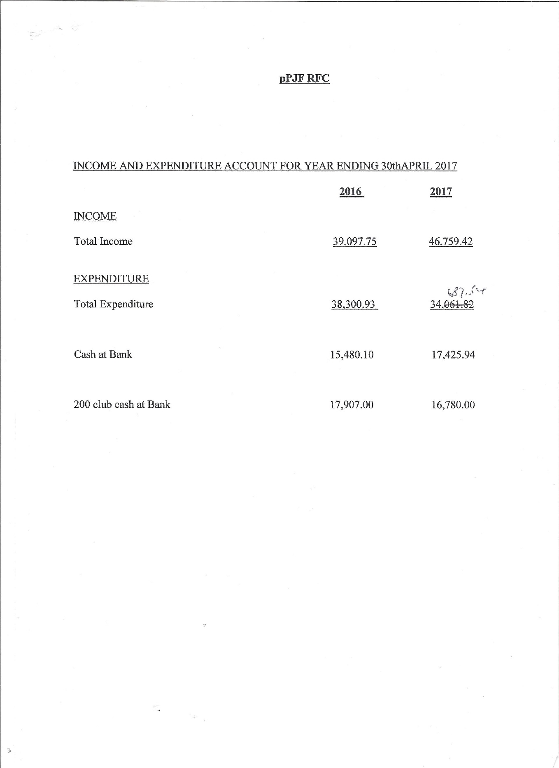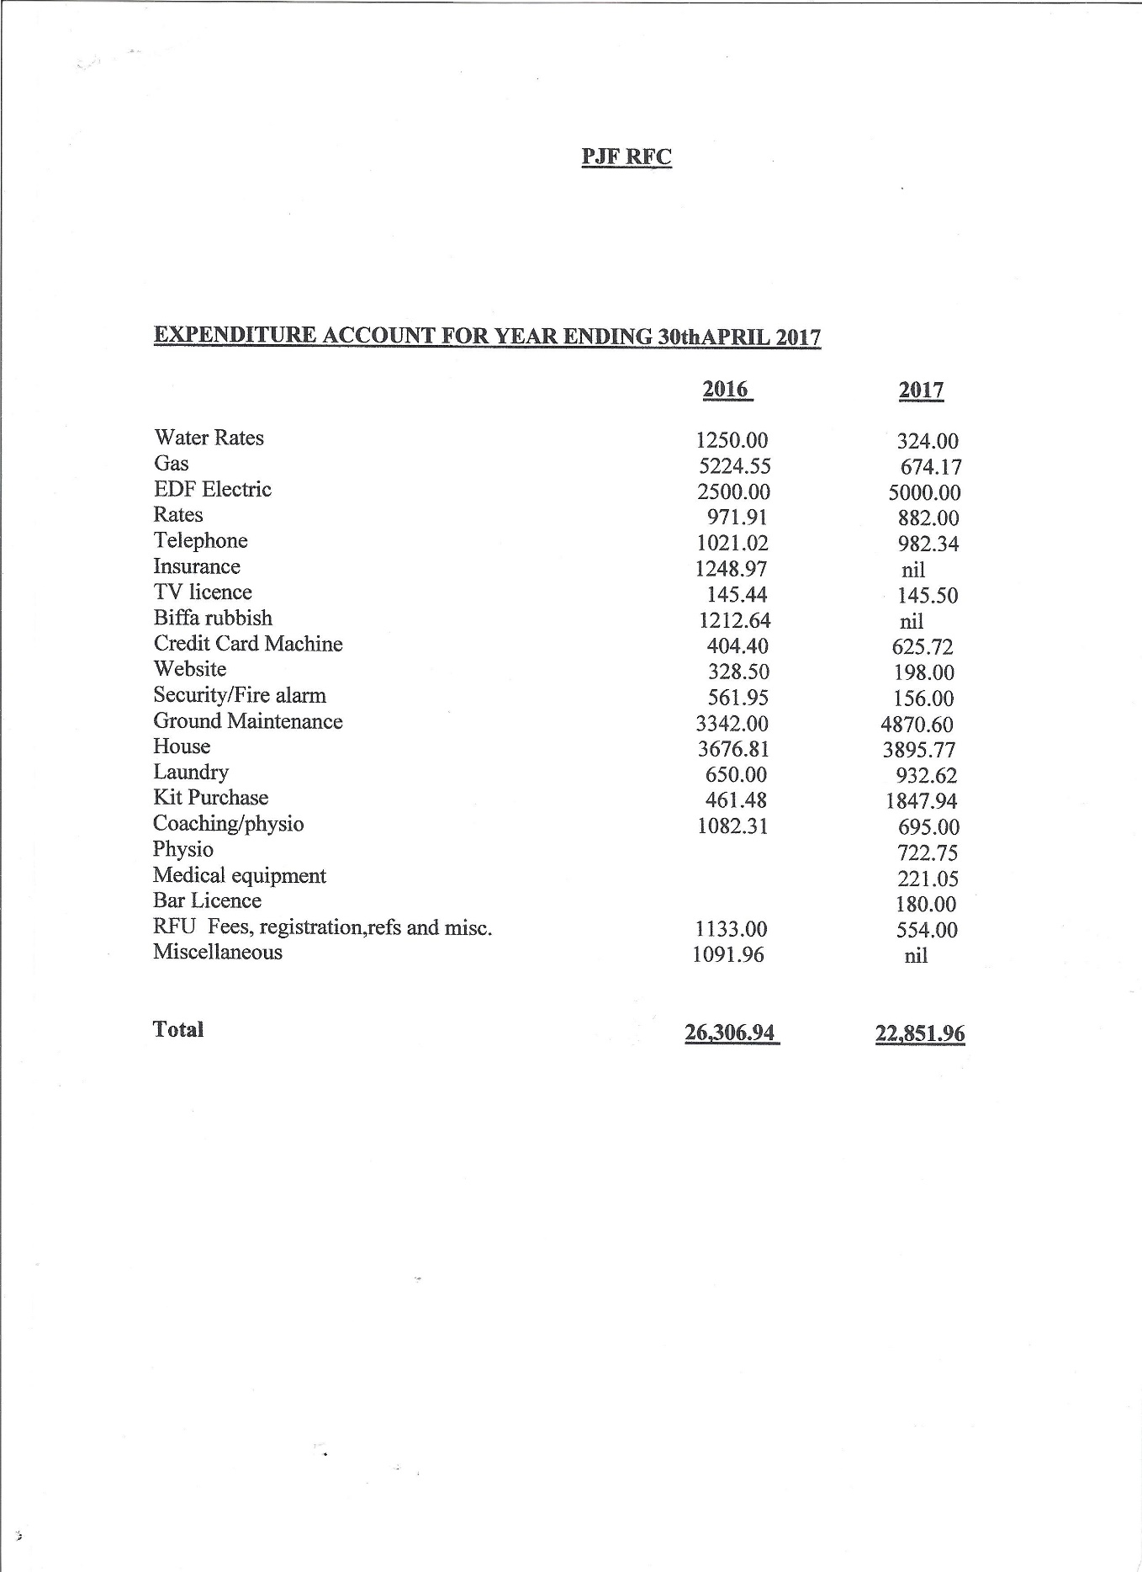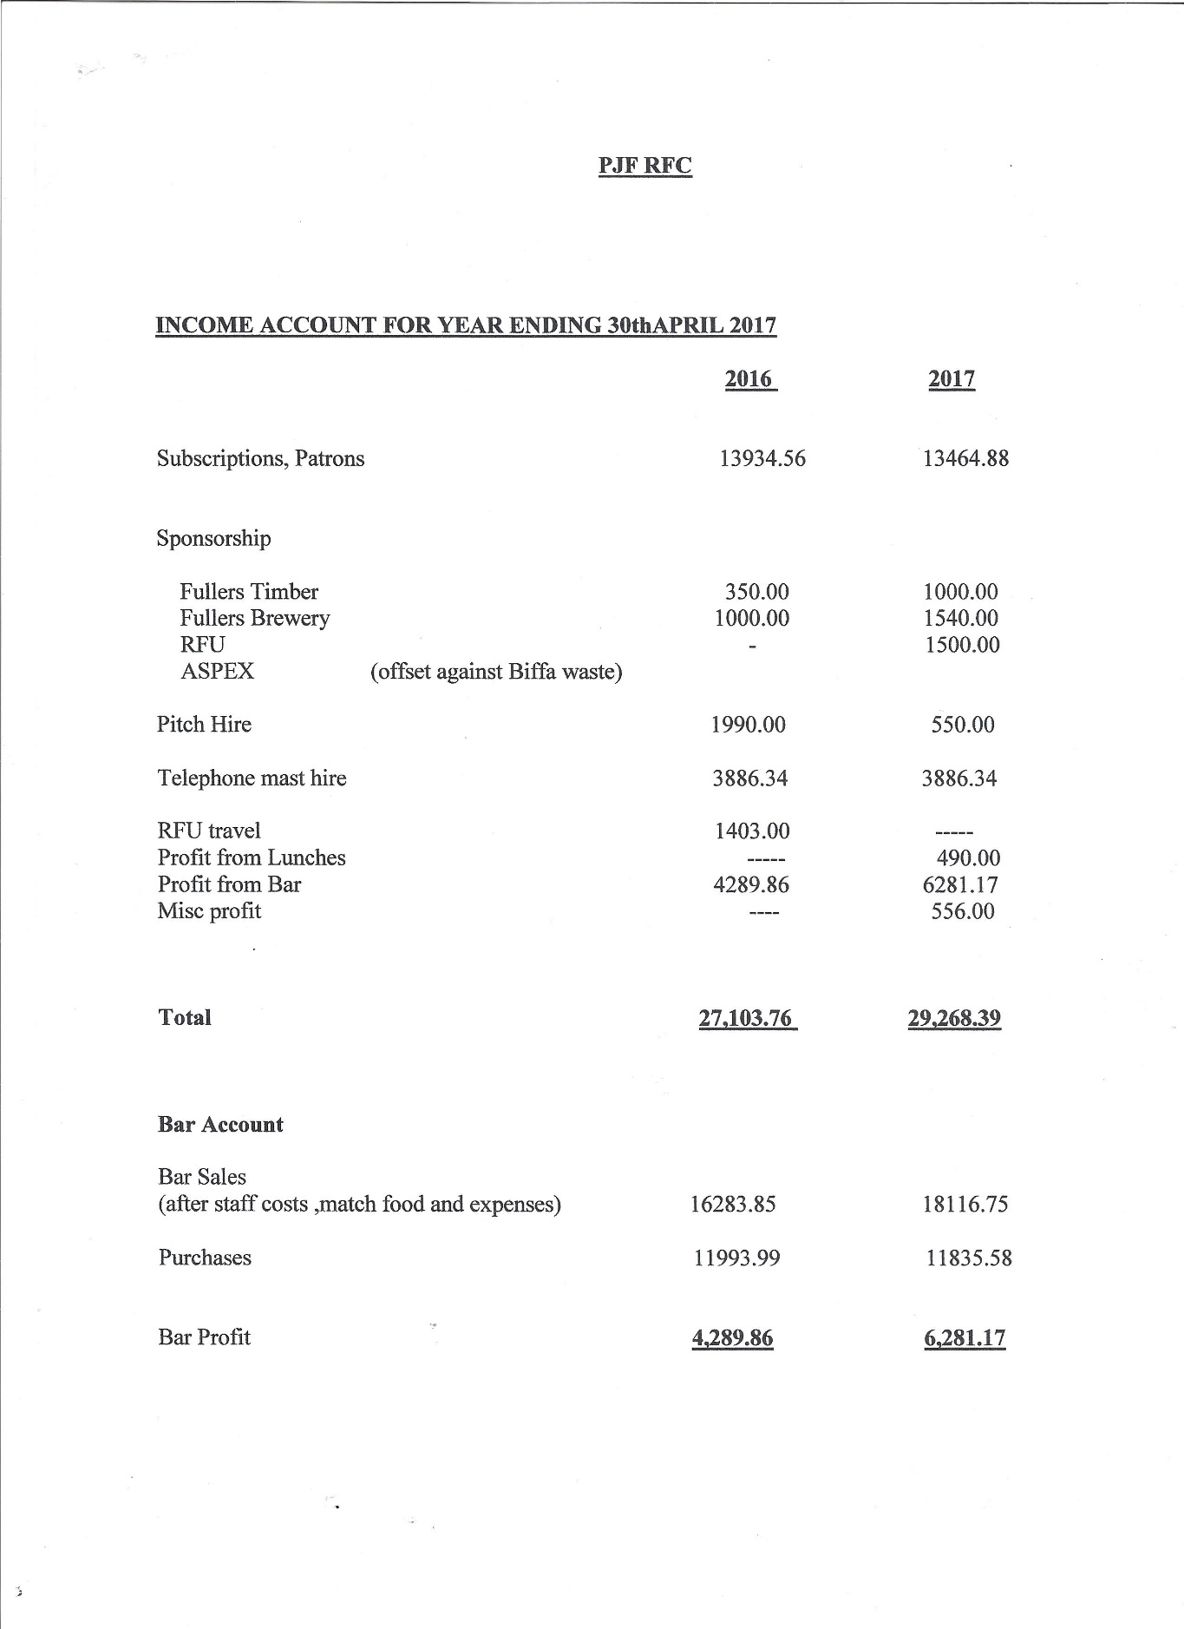

Secretary’s Report | The year has been very eventful. At the end of the season we have been relegated to Surrey Division 2. This might be considered a total failure until you look at it in the perspective of the whole year.  We started the year in a terrible state. Relegated from London SW3 for not completing our fixtures during the 2015/16 season and penalized 10 league points to be carried over to the 2016/17 season. At that stage we no side and no coach.  After working with Surrey and signing up to the Return to Rugby initiative we attended a number of sessions run by the County which largely focused on using social media to create a noise. Phil Jones, who had agreed to take on the captaincy started touch in June. Reintroducing the enjoyment of the game was the priority. Over the summer we attracted a number of new players to the club and Iain Greenwood and Shane van der Schiff came on board to do the coaching.  The club also looked to improve its social media presence and inject more life into the web site.  Numbers began to grow and the start of the season saw PJF take a side down to the IOW for a warm up game at the beginning of September.  The season started with a draw against O Emanuel and a win against Chipstead and the 10 point deficit did not look insurmountable. However, as the season progressed we found that the league was one where everyone could beat everyone else in the league, and we found that closing the gap was harder than initially thought. the side tried hard without the necessary improvement in quality. By the end of the season the side had fallen short and we have been subsequently relegated. Nevertheless we are unquestionably in a better place than we were at the end of the 2015/16 season. We have a good solid squad of regular players. A side that is still very young and holds a lot of promise if they choose to realise it. Interest from others in joining the club. The main people to thank for this are Phil, Iain, Shane and Julian Emmanuel and the club thanks them for their tireless work throughout the season.  I would also like to put on record the fantastic work the Julian Emmanuel did throughout the season. The Marlins turned out week after week and turning in great performances week after week. The side were runners up in their league. Julian would never say never and his achievements and success reflect this never say die attitude.  At the end of the season the coaches and captains sat down and critically looked at the seasons achievements and disappointments. At a very constructive evening we had started to formulate a plan for the future.  The club has already started touch over the Summer already attracting 20+ players each Monday. We will be looking to introduce more structure to the sessions in July when we will start to train twice a week. New training equipment has been purchased with the grateful help of Surrey RFU.  Warm up games are being organized against local sides with another trip to the Isle of Wight is on the cards.  The rebuilding is still very fragile and we cannot take anything for granted. We will continue to strive to get things better and to improve. We are looking to further improve the infrastructure by having better pitch side management in place to support the players on the pitch, and the hope is that the club will be able to start to move back up the leagues soon.  I would like to place on record the club’s gratitude to the RFU, Surrey RFU and in particular Penny Carr and Steve Williams for their time and advice and belief that we will turn the club around. I would also like to acknowledge the contribution of Jess Lee who provided physio support throughout the season. Jess has proved to be enthusiastic and self motivated in her work with the club and we thank her for her enthusiasm and good humour as well as her developing professional skills.  The job is not yet done. The club has hugely exciting times ahead of it. We plan to build on last season’s achievements and to build our communications with the school and other potential players and continue to grow. It is challenging but it will be rewarding.
Future Opportunities | Richard Cebreiro talked through a long-term development opportunity for the club that had arisen because of the possibility of developing the ground at Warlingham. It would mean moving the club from the current site to a new ground in Warlingham. This would mean the club had security of tenure as they would be in control of the ground and would not have to pay rental as we do at the moment. A special general meeting of the John Fisher School Old Boys Association would be held in September when a mandate would be sought to progress the project by negotiating with a potential developer. Questions were taken from the floor. When it came to moving the club would not change its name and would look to taking elements of the current club house to ensure the heritage of the club was maintained.
Election of Officers | Nominee Proposed Seconded  Chairman Bryan Whicher  Treasurer Graham Brookes  Secretary Niel Kenny  1st Team Capt Phil Jones  Marlins Capt Paddy O’Neil Assisted by Julian Emmanuel  Vets Captain Joe Dilieto  Social Sec Connor Murphy  Sponsorship Sec  Medical officer Julian Emmanuel  Fixture Secretary Chris Doyle  Kit and merchandise Neil Leather  Coaching Iain Greenwood Shane van der Schiff
 | Other members of the committee would be appointed by the committee

